APPLE- PREDICTING STOCK MARKET

Research methods for Business Administration

FABIZ, IMBA, 2nd year

Antor Andreea-Maria

Spataru Catalin Gabriel

Vijan Alice-Stefania

1. **Introduction**

The stock market represents a complex ecosystem where numerous factors interact to influence the price movements of individual stocks. Among these stocks, Apple Inc. stands as one of the most prominent and influential companies, with its products, innovations, and market performance often dictating broader market trends.

Predicting the stock market is a challenge that has intrigued investors, analysts, and researchers for decades, as successful forecasting can yield significant financial rewards while poor predictions can lead to substantial losses.

Using historical stock data, financial indicators, and machine learning algorithms, we seek to develop robust predictive models capable of providing insights into future price movements. The key objective is to forecast the closing stock price (‘Close’) for a specified number of days into the future, leveraging a simple linear regression model

Throughout this project, we will explore various methodologies, evaluate model performance, and refine our approach to ensure the reliability and robustness of our predictions. Ultimately, our goal is to contribute to the advancement of predictive modeling techniques in the field of finance and provide actionable insights that can drive informed decision-making in the realm of stock market investment, with a specific focus on Apple Inc.

1. **Methods**
2. *Dataset*

The original database used was downloaded from Google Finance. For our analysis, we only needed a part of it, so we proceeded to use a few formulas in order to retrieve each column of data.

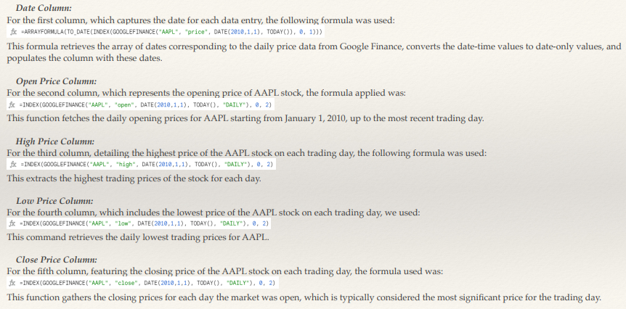

Each of the formulas was entered into the first cell of their respective columns in a Google Sheet. Consequently,the formulas automatically populated the columns with historical data from the specified start date to the date of retrieval.

The compilation of historical stock price data was then downloaded as a CSV file names AppleStockMarket.csv.



1. *Files used*

Proiect_Andreea.py: Python script for the stock price prediction model.

AppleStockMarket.csv: This document contains istorical data file with daily stock prices.

Predicted_Apple_Stock_Prices.csv: This document contains the model's predictions (assumed output).

Predicted_Apple_Stock_Prices.png: This document represents a graphical representation of predicted prices (assumed output).

1. *Data format and Structure*
2. Input data

The input CSV file, AppleStockMarket.csv, has the following columns:

* + Date: The trading date in DD/MM/YYYY format.
  + Open: The stock's opening price for the trading day.
  + High: The highest price of the stock for the trading day.
  + Low: The lowest price of the stock for the trading day.
  + Close: The stock's closing price for the trading day.

The data is sorted chronologically, starting from the earliest date.

1. Output data

The output of our script includes two main components:

·       **Predicted_Apple_Stock_Prices.csv**: A CSV file containing the date and the corresponding predicted closing price for each future date within the specified prediction interval. **·       Predicted_Apple_Stock_Prices.png**: An image file showing a line plot of the predicted closing prices over time.

1. *Linear Regression Overview*

Linear regression is a fundamental statistical and machine learning technique used to model the relationship between a dependent variable and one or more independent variables.

In this project, specifically, the dependent variable is the 'Close' price of Apple's stock, and the independent variable is the number of days since the start of the dataset. The relationship is assumed to be linear, described by the equation:

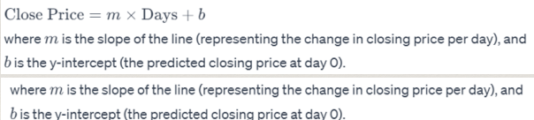

1. *Data Preprocessing*

The script starts by importing necessary libraries and reading the CSV file. It then processes the data, converting dates to a numerical format and sorting the data chronologically.

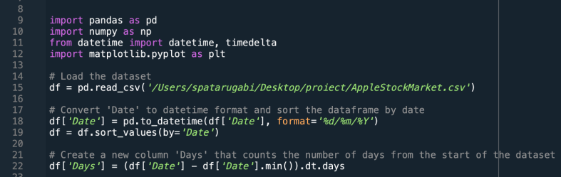

1. *Model training*

It calculates linear regression parameters (slope and intercept) using the least squares method, where the 'Days' column is the independent variable and the 'Close' price is the dependent variable.

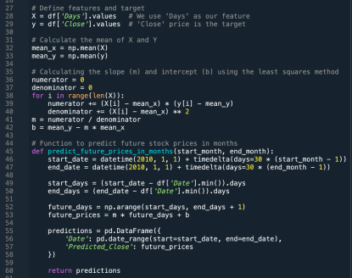

1. *Prediction function*

A function to predict future prices takes the number of days into the future and uses the linear model to forecast the closing prices.

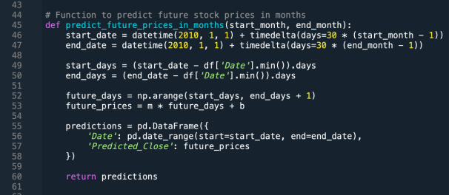

1. *Plot generation and data export*

The script generates a plot using Matplotlib and exports the predictions to a CSV file.

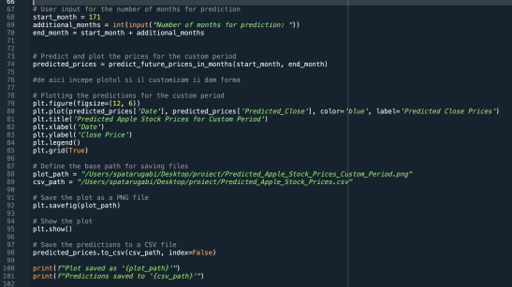

1. *Code execution*

We proceeded to run the script via the command line and we provided the inputs as prompted.

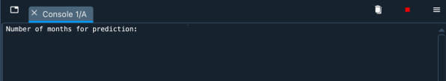

In order to calculate the predictiction we used the historical data for the last 171 months, which we manually introduced in code.

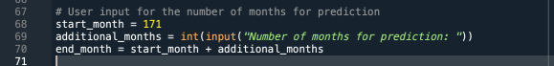

1. **RESULTS**

The generated output files, including the CSV and PNG formats, serve as valuable tools for analyzing predicted stock price trends and evaluating the performance of the predictive model. These files enable users to delve into the forecasted stock price movements over different time periods, allowing for comparisons and insights into the model's accuracy and reliability.

In our specific example, we have forecasted Apple Inc.'s stock prices for a 12-month period, offering a glimpse into potential future trends. By adjusting the time periods or incorporating additional data, users can further refine their analyses and make informed decisions regarding investment strategies or market predictions.

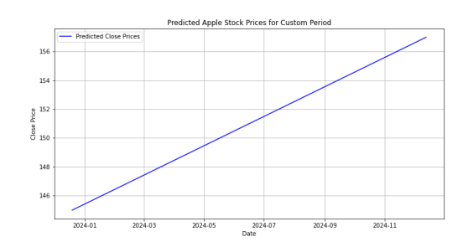

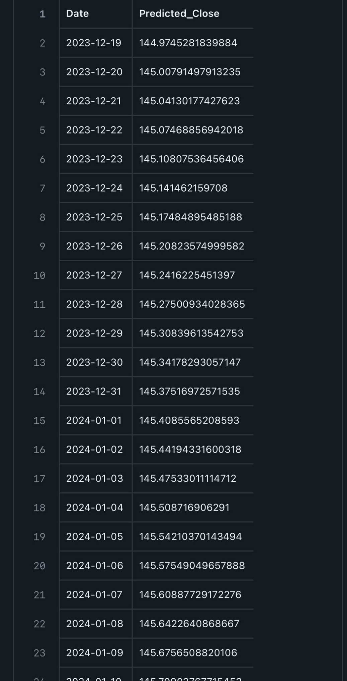

1. **DISCUSSION**

This code snippet serves a crucial role in the realm of financial analysis by enabling the prediction of future stock prices for Apple Inc. Such predictive capabilities are invaluable to investors and financial analysts seeking to anticipate market trends and make informed investment decisions.

Beginning with the loading and preprocessing of historical stock market data for Apple, the code meticulously organizes and prepares the dataset for analysis. Through the utilization of linear regression, a fundamental statistical technique, the code extrapolates future stock price trends based on historical patterns. This predictive model offers flexibility by allowing users to specify the desired time horizon for their forecasts.

Moreover, the code employs data visualization techniques to convey these predictions effectively. By generating a visually intuitive plot of the projected stock prices over time, users can gain deeper insights into potential future trends. Additionally, the code ensures accessibility and usability by saving both the plot and the underlying data predictions to external files for further analysis and reference.

In essence, this code facilitates enhanced decision-making in the financial domain by providing actionable insights into the future trajectory of Apple's stock prices. Its intuitive functionality and practical utility make it a valuable tool for navigating the complexities of the stock market landscape.